Group: bioluminescence

Members: Justin Cabral, Jonathan Duran, Humberto Martinez, Miles Gregg

Credentials:

* Corporate:
  + Username: corporate
  + Password: password
* Managers:
  + 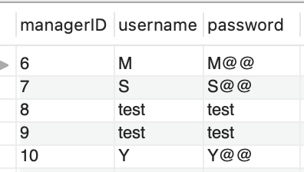

## GUI landing page:

* <http://cs509-group-project.s3-website-us-east-1.amazonaws.com/>

**Manager process shipment Updates:**

* We have updated the front-end process shipment page to reflect the following example inputs.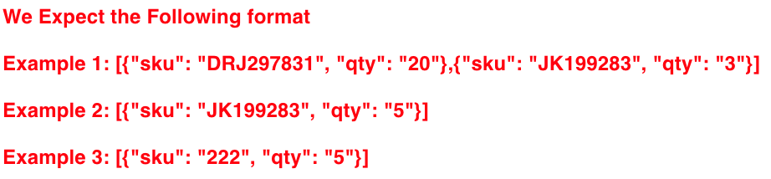
* **Both the variable names reflect the input examples “sku” & “qty”, also the input values are allowed to be enclosed in quotes.**